“WorkForce One”
A PROJECT REPORT
SUBMITTED BY
Aadil Talati (ET24MTCA066)

UNDER THE GUIDANCE OF

Dr. Nidhi Mehta
In fulfilment for the award of the degree
Of
Master of Computer Applications
At

Sarvajanik College of Engineering and Technology, Surat.
Sarvajanik University
May, 2026

 |   Sarvajanik University  Sarvajanik College of Engineering & Technology, Surat.  Department of Computer Applications

Date: 02/05/2026

CERTIFICATE

This is to certify that the project entitled “WorkForce One” has been submitted by Aadil Talati (ET24MTCA066) towards the fulfillment of the degree of Master of Computer Applications (M.C.A) in (4th Semester) of Sarvajanik University, Surat during the academic year 2025-2026.

Dr. Nidhi Mehta | Dr. Gayatri Kapadia (Head- Department of Computer  Applications)
(Guide’s Signature)

Examiner’s Signature
1.
2.

Self-Declaration

Title of the Project: WorkForce One

Enrollment Number | Student Name
ET24MTCA066 | Aadil Talati

I hereby declare that the above-mentioned project report submitted by us has been prepared by me and in original in its content and it has not been submitted anywhere else.

I confirm that the report is only prepared for academic requirements, not for any other purpose. It might not be used by anyone for any other purpose.

Student’s Signature

(Aadil Talati)

Acknowledgement

The success and final outcome of this project required a lot of guidance and assistance from many people, and we are extremely fortunate to have got this all along the completion of our project work. Whatever we have done is only due to such guidance and assistance.

We would not forget to thank Dr. Gayatri Kapadia, Head of Department and Project guide Dr. Nidhi Mehta, and all other Assistant professors of Sarvajanik College of Engineering & Technology, Surat. Who took keen interest on our project work and guided us all along, till the completion of our project work by providing all the necessary information for developing a good system.

We are extremely grateful to her for providing such a nice support and guidance though she/he had busy schedule managing the college dealings.

We are thankful and fortunate enough to get support and guidance from all Teaching staffs of Master of Computer Application Department which helped us in successfully completing our project work. Also, we would like to extend our sincere regards to all the non-teaching staff of Master of Computer Application Department for their timely support.

Thanking to all,

Aadil Talati (ET24MTCA066)

Index

Sr. No | Content | Page No.
1. | Introduction
 | - Existing System
 | - Need for the New System
 | - Objective of the New System
 | - Problem Definition
 | - Core Components
 | - Project Profile
 | - Assumptions and Constraints
 | - Advantages and Limitations of Proposed System
2. | Requirement Determination & Analysis
 | 2.1. Requirement Determination
 | 2.2. Targeted Users
3. | System Design
 | 3.1. Introduction of Quality Assurance
 | 3.2. Testing Strategy
 | 3.2.1. Functionality Testing
 | 3.2.2. Performance Testing
 | 3.2.3. Regression Testing
 | 3.2.4. Unit Testing
 | 3.2.5. Integration Testing
 | 3.2.6. Security Testing
 | 3.2.7. Smoke Testing
 | 3.2.8. User Acceptance Testing
 | 3.3. Reports
 | 3.3.1. Test Plan
 | 3.3.2. Test Scenarios
 | 3.3.3. Test Cases
 | 3.3.4. Bug Report
4. | Development
 | 4.1. Coding Standards
 | 4.2. Screen Shots
5. | Agile Documentation
 | 5.1. Agile Project Charter
 | 5.2. Agile Roadmap / Schedule
 | 5.3. Agile Project Plan
 | 5.4. Agile User Story (Minimum 3 Tasks)
 | 5.5. Agile Release Plan
 | 5.6. Agile Sprint Backlog
 | 5.7. Agile Test Plan
 | 5.8. Earned-value and burn charts
6. | Proposed Enhancement
7. | Conclusion
8. | Bibliography

1.Introduction

WorkForce One is a comprehensive field-service management platform designed to bridge the gap between administrative teams and field technicians through seamless digital workflows. The platform features a dual-interface system—an Angular-based web portal for administrators and a mobile application for field technicians—ensuring efficient coordination and real-time communication.
Administrators can efficiently manage service operations by creating and assigning repair jobs, scheduling tasks, and maintaining centralized databases for customers, products, and services. The web portal provides a unified dashboard to monitor field activities, track job progress, and generate invoices and service reports, enabling better operational control and decision-making.
Field technicians benefit from a structured mobile interface that provides a clear view of assigned tasks, daily schedules, and reminders. They can access job details, navigate to service locations, update task statuses in real time, and upload essential field data such as photos and service notes. This ensures accurate documentation and transparency throughout the service lifecycle.
Upon completion of service tasks, the system facilitates the automatic generation of detailed reports, professional invoices, and order summaries within the admin dashboard. This reduces manual paperwork, minimizes errors, and improves overall efficiency.
WorkForce One strengthens the connection between office planning and field execution by promoting accountability, transparency, and streamlined communication. The platform is built with scalability in mind and offers strong potential for future enhancements, including intelligent route optimization, real-time vehicle tracking, IoT-based preventive maintenance alerts, and deeper integration with enterprise ERP systems.
Overall, WorkForce One is a forward-thinking solution aimed at transforming field operations into a more agile, efficient, and digitally empowered ecosystem.

1.1 Existing System

The traditional field-service management system mainly depends on physical paperwork, phone calls, and manual tracking methods such as whiteboards. This approach has several limitations:
- Time-consuming processes due to continuous manual coordination and scattered communication between office staff and field technicians.
- High chances of human error, which can result in missing field data, misplaced invoices, or unresolved customer service requests.
- Poor record management, as there is no centralized system to store job history, customer details, or service-related photos and documents.
- Delayed billing process, since invoices are often created only after technicians return to the office with handwritten notes.

1.2 Need for the New System

A digital service platform like WorkForce One is important to overcome the limitations of traditional systems. It provides several key benefits:
- Centralized Data Management: All important information such as customer details, task schedules, service records, photos, and invoices are stored in one secure system.
- Real-Time Task Updates: Field technicians can instantly update the status of their tasks (e.g., in progress, completed), allowing the admin team to stay informed at all times.
- Automated Document Generation: The system automatically creates service reports and invoices using technician inputs and uploaded data, saving time and reducing manual work.
- Improved Accountability and Verification: Technicians can upload photos and documents as proof of completed work, helping to avoid confusion and resolve customer disputes.
- Role-Based Access: The platform provides separate interfaces for admins and technicians, ensuring each user has access only to the tools and information they need.
1.3 Objective of the New System

The main objective of WorkForce One is to create an efficient and organized digital system for managing field-service operations. The key objectives include:
- Seamless Office-to-Field Workflow: Provide a structured process for creating, assigning, executing, and reviewing field service tasks smoothly.
- Secure Data and Media Upload: Allow technicians to upload photos, documents, and service details directly from the mobile app, ensuring safe and accurate record updates.
- Efficient Task Assignment and Scheduling: Enable admins to monitor technician availability, assign tasks digitally, and handle urgent or priority jobs effectively.
- Automated Reports and Invoices: Reduce manual data entry by automatically generating service reports and invoices based on real-time updates from the field.
- Customer and Organization Management: Support management of multiple clients or organizations while keeping their data separate and well-organized for different service needs.

1.4 Problem Definition
Field service and repair industries face several important challenges that affect efficiency and service quality:
- No real-time visibility: There is no proper system to track when technicians start, pause, or complete their tasks in the field.
- Delayed billing process: A long-time gap exists between job completion and generating final invoices for customers.
- Poor document management: It is difficult to store and quickly access important documents such as service records, blueprints, and media files from past jobs.
- Missed follow-ups: Important tasks and reminders are often missed due to the absence of an integrated reminder or notification system.
These issues lead to delays, reduced productivity, and poor coordination between the office and field teams.

1.5 Core Components
The WorkForce One platform consists of several interrelated components, each playing a vital role in streamlining field-service operations.

1. User Authentication & Authorization Module:
- Admins and Technicians: Secure login with role-based access using JWT authentication.
- Ensures that each user can only access features relevant to their role.
2. Task & Repair Job Management Module:
- Admins create and manage service jobs with details such as location, priority, and job description.
- Tasks are assigned digitally to specific technicians for execution.
3. Mobile Execution Module:
- Technicians can view their assigned tasks in a “To-Do” list.
- Update job status (in progress, completed), add notes, and manage action items directly from the mobile app.

4. Media & Document Upload Module:
- Technicians can upload photos and documents (before/after work) as proof of service.
- Supports real-time uploads linked to specific tasks for proper record-keeping.

5. Invoice & Reporting Module:
- Automatically generates service reports and invoices based on technician inputs.
- Includes job details, pricing, and customer information for accurate billing.

6. Master Resource Management Module:
- Manages essential system data such as tenants, subcontractors, contacts, products, and service categories.
- Ensures organized and structured data for smooth operations.
1.6 Project Profile

Project Name | WorkForce One
Type | Field Service Management System
Technology Used | - Frontend: Angular 19+ (Web Admin Portal)  - Backend: ASP.NET Core API (C#)  - Database: Microsoft SQL Server (Entity Framework Core)  - Authentication: JWT (JSON Web Tokens)  - Reporting/Export: HTML to PDF Conversion
Target Users | - Admins/Dispatchers: Manage tasks, track progress, generate invoices  - Technicians: View jobs, update statuses, upload task proof
Key Features | - Task creation and remote assignment  - Real-time media attachments  - Auto-generation of invoices and service reports  - Reminder and action item tracking

1.7 Assumption and Constraints
Assumption:
- Technicians will have smartphones with a working camera and internet access in the field.
- Admin staff will have stable internet connectivity for monitoring and managing operations.
- Product prices, service charges, and other required data are already configured correctly in the system.
- Users have basic knowledge of using mobile apps and web systems.

Constraints:
- Data and image uploads may fail or be delayed in low or no internet areas.
- Low-end devices may face performance issues with large files or heavy usage.
- Technicians may need time and training to adapt to the new digital system.
- Handling many users or data simultaneously may require system optimization.

1.8 Advantages and Limitations of The Proposed System
Advantages:
- Improved Coordination: Enables real-time task tracking, reducing dependency on phone calls and manual follow-ups between admins and technicians.
- Instant Invoice Generation: Automatically generates invoices as soon as a job is completed, leading to faster billing and improved cash flow.
- Reliable Proof of Service: Allows technicians to upload photos and documents, creating a clear and verifiable record of completed work.
- Centralized Information System: Stores all customer data, job history, and service records in one place, making it easy to access and manage information.
- High Scalability: Designed to support multiple users, organizations, and large volumes of data without affecting performance.
Limitations:
- Limited Offline Functionality: The system relies on internet connectivity, so operations may be restricted in areas with poor or no network access.
- Increased Battery Usage: Features like GPS tracking and continuous data updates can lead to higher battery consumption on mobile devices.

2. Requirement Determination & Analysis

2.1 Requirement Determination:

The WorkForce One platform is designed to meet the operational needs of administrators and field technicians by providing efficient task management, real-time updates, and automated reporting. The requirements are categorized as functional and non-functional.

Functional Requirements:
1. User Authentication & Role Management:
- Secure login using JWT-based authentication for Admins and Technicians.
- Role-based access control to restrict features based on user type.

2. Dashboard & Task Management:
- Admin dashboard to view active, pending, and completed tasks.
- Ability to create, assign, and manage service jobs with details like location, priority, and schedule.

3. Service Execution & Tracking:
- Technicians can view assigned tasks and update their status (in-progress, completed).
- Real-time updates ensure admins can monitor job progress efficiently.

4. Media & Data Handling:
- Upload and manage service-related media such as before/after images.
- Link uploaded data directly to specific service tasks for proper documentation.

5. Invoicing & Reporting:
- Automatic generation of service reports and invoices based on completed tasks.
- Includes job details, pricing, and customer information.

Non-Functional Requirements:
1. Performance:
- Efficient handling of large task data using optimized filtering, sorting, and pagination.

2. Security:
- Secure API endpoints with JWT authentication and data protection mechanisms.
- Ensures role-based access and prevents unauthorized data usage.

3. Usability:
- Simple and intuitive user interface for both admin web portal and technician mobile app.

4. Maintainability & Scalability:
- Built using modern development practices (ASP.NET Core architecture, modular design).
- Supports system growth with increasing users and data volume.

2.2 Targeted Users

The WorkForce One platform is designed for two primary user roles: Admins/Dispatch Staff and Field Technicians.

1. Admin:
- Use the Angular-based web portal for managing operations.
- Handle data entry for customers, products, tenants, and other system resources.
- Create, manage, and assign service tasks or repair jobs to technicians.
- Monitor task progress and generate final invoices and service reports.

2. Field Technicians:
- Access the system through the mobile application.
- Receive task assignments, reminders, and view their daily job list.
- Capture and upload photos or documents as proof of completed work.
- Update task status and mark jobs as completed directly from the app.

By addressing the needs of both user roles, WorkForce One ensures smooth coordination between office staff and field technicians, enabling efficient and transparent field-service operations.

3.System Design
3.1 Introduction of Quality Assurance
Quality Assurance (QA) is an important process that ensures the WorkForce One functions correctly, reliably, and meets user requirements. In this project, QA was primarily carried out through manual testing, where different features of the system were tested by executing test cases and observing the results.
Manual testing was used to verify core functionalities such as user authentication, task management, data handling, and report generation in the Angular-based web portal and ASP.NET Core backend. Each feature was tested under different scenarios to identify bugs, ensure correct behavior, and validate system performance from a user’s perspective.
This approach helped in detecting errors early, improving system usability, and ensuring that the application delivers a smooth and consistent user experience. Overall, manual testing played a key role in validating the system’s functionality and ensuring that it meets the expected quality standards.

3.2 Testing Strategy
The testing strategy for the WorkForce One was carried out using a structured manual testing approach, ensuring that all core functionalities work correctly and provide a smooth user experience.
3.2.1 Functional Testing:
• Verified core functionalities such as login, task creation, task assignment, and report generation.
• Ensured proper navigation between different modules of the application.
• Checked CRUD operations (Create, Read, Update, Delete) for tasks, users, and data entries.
3.2.2 Performance Testing:
• Observed system response time during task loading and data retrieval.
• Checked for delays while switching between pages and performing actions.
3.2.3 Regression Testing:
• Re-tested previously working features after updates or bug fixes.
• Ensured that new changes did not break existing functionalities.

3.2.4 Unit Testing:
• Basic validation of individual functions during development.
• Ensured that core operations like saving and updating data work correctly.
3.2.5 Integration Testing:
• Verified smooth interaction between frontend (Angular) and backend (ASP.NET Core).
• Ensured proper data flow between modules like tasks, users, and reports.
3.2.6 Security Testing:
• Checked authentication and access control for different user roles.
• Ensured that unauthorized users cannot access restricted features.
3.2.7 Smoke Testing:
• Performed quick testing after deployment to verify that the application loads properly.
• Ensured that major features are working without critical issues.
3.2.8 User Acceptance Testing (UAT):
• Validated the system from an end-user perspective.
• Ensured the application is easy to use and meets user requirements.

3.3 Reports

3.3.1. Test Plan:
The test plan for WorkForce One ensures that the web application works correctly and meets user requirements. Testing was mainly focused on checking core features like login, task management, order handling, and report generation.
1. Test Plan ID: TP-WFO-01
2. Project Name: WorkForce One
3. Prepared By: Aadil Talati
4. Date: 20 March 2026
5. Application Type: Web Application
6. Testing Type: Manual Testing

Scope of Testing:
Testing includes the following modules:
• Login & Authentication
• Dashboard
• Order Management
• Reports & Invoices
• To-Do Management
• UI/UX
Testing Approach:
Manual testing was performed by executing different test scenarios and checking system behaviour. Both normal and error cases were tested to ensure proper functionality.

3.3.2. Test Scenarios:
Test scenarios are used to verify different functionalities of the WorkForce One web application. These scenarios represent real user actions and help ensure that the system works correctly under various conditions.
Each test scenario includes a unique ID, description, test type, and expected result.

Test Scenario ID | Test Scenario | Test Type | Expected Result
TS001 | Verify admin login with valid credentials | Functional | User logs in successfully
TS002 | Verify login with invalid credentials | Validation | Error message displayed
TS003 | Verify session logout after inactivity | Security | User is logged out automatically
TS004 | Verify dashboard loads correctly | Functional | Dashboard data displayed
TS005 | Verify order creation | Functional | Order created successfully
TS006 | Verify order editing | Functional | Updated data saved
TS007 | Verify order deletion | Functional | Order removed
TS008 | Verify technician assignment | Functional | Technician assigned correctly
TS009 | Verify order status update | Functional | Status updated properly
TS010 | Verify report generation | Functional | Report generated successfully
TS011 | Verify invoice generation | Functional | Invoice created correctly
TS012 | Verify invoice printing | Functional | Invoice prints without error
TS013 | Verify to-do task creation | Functional | Task added successfully
TS014 | Verify to-do task update | Functional | Task updated
TS015 | Verify to-do task deletion | Functional | Task deleted
TS016 | Verify search functionality | Functional | Correct results displayed
TS017 | Verify filter functionality | Functional | Filter works correctly
TS018 | Verify media upload | Functional | Files uploaded successfully
TS019 | Verify UI alignment | UI/UX | Elements aligned properly
TS020 | Verify responsiveness | UI/UX | Layout adjusts correctly
TS021 | Verify validation for empty fields | Validation | Error message shown
TS022 | Verify API error handling | Negative Test | Proper error message shown
TS023 | Verify navigation between modules | Usability | Correct page opens
TS024 | Verify data consistency across modules | Integration | Same data shown everywhere
TS025 | Verify logout functionality | Functional | User logged out successfully

3.3.3. Test Case:
Test cases are used to validate specific functionalities of the WorkForce One. Each test case includes steps, expected results, and actual outcomes to ensure that the system works correctly. These test cases are derived from real manual testing performed on different modules of the system.

Test Case ID | Module | Test Case Description | Expected Result | Status
TC001 | Login | Verify login with valid credentials | User logs in successfully | Pass
TC002 | Login | Verify login with invalid credentials | Error message displayed | Pass
TC003 | Login | Verify login with empty fields | Validation message shown | Pass
TC004 | Login | Verify session logout after inactivity | User is logged out automatically | Pass
TC005 | Dashboard | Verify dashboard loads correctly | Dashboard displayed with data | Pass
TC006 | Dashboard | Verify dashboard data accuracy | Correct values shown | Fail
TC007 | Dashboard | Verify navigation between modules | Correct module opens | Pass
TC008 | Order | Verify order creation | Order created successfully | Pass
TC009 | Order | Verify order editing | Changes saved correctly | Fail
TC010 | Order | Verify order deletion | Order removed successfully | Fail
TC011 | Order | Verify technician assignment | Technician assigned correctly | Pass
TC012 | Order | Verify order status update | Status updated correctly | Pass
TC013 | Request Order | Verify request order creation | Request created successfully | Pass
TC014 | Reports | Verify report generation | Report generated successfully | Fail
TC015 | Reports | Verify report printing | Report prints correctly | Fail
TC016 | Invoice | Verify invoice generation | Invoice created successfully | Pass
TC017 | Invoice | Verify invoice printing | Invoice prints correctly | Fail
TC018 | To-Do | Verify task creation | Task added successfully | Pass
TC019 | To-Do | Verify task update | Task updated correctly | Pass
TC020 | To-Do | Verify task deletion | Task deleted successfully | Pass
TC021 | Search | Verify search functionality | Correct results displayed | Fail
TC022 | Filter | Verify filter functionality | Filter works correctly | Fail
TC023 | Media | Verify file upload | File uploaded successfully | Pass
TC024 | UI | Verify UI alignment | Elements aligned properly | Fail
TC025 | UI | Verify responsiveness | Layout adjusts correctly | Fail
TC026 | Validation | Verify required field validation | Error message shown | Pass
TC027 | System | Verify API error handling | Proper error message displayed | Pass
TC028 | Integration | Verify data consistency | Same data across modules | Pass
TC029 | Security | Verify unauthorized access restriction | Access denied | Pass
TC030 | Security | Verify logout functionality | User logged out successfully | Pass

3.3.4. Bug Report:
Bug reports document the defects identified during manual testing of the WorkForce One web application. These issues were found across multiple modules such as dashboard, orders, reports, UI, and system behavior. Bugs are categorized based on severity to prioritize fixes.
Bug ID | Description | Severity | Status
BG001 | Dashboard showing incorrect data values | High | Closed
BG002 | Order creation not working properly | High | Closed
BG003 | Edit order functionality not saving changes | High | Resolved
BG004 | Request order not deleting properly | Medium | Closed
BG005 | Report generation stuck in loading | High | Closed
BG006 | Report printing not working | Medium | Resolved
BG007 | Invoice print not working | Medium | Closed
BG008 | Invoice showing unreadable format | Low | Closed
BG009 | Search functionality not returning results | Medium | Closed
BG010 | Filter not applying correctly | Medium | Closed
BG011 | To-do checkbox not working | Medium | Resolved
BG012 | Validation messages not displayed properly | Low | Closed
BG013 | Contact not getting created | High | Closed
BG014 | Technician data not displayed correctly | Medium | Closed
BG015 | UI alignment issues across screens | Low | Closed
BG016 | Application not responsive on smaller screens | Medium | Resolved
BG017 | Media upload preview not displaying | Low | Closed
BG018 | Navigation between modules sometimes fails | Medium | Closed
BG019 | Session not expiring after inactivity | High | Resolved
BG020 | System crash when accessing specific modules | High | Closed

4.Coding Standards
4.1 Coding Standards
To ensure code quality, maintainability, and scalability, the following coding standards are followed in
WorkForce One:
1. Code Structure & Organization:
- Follow a modular architecture with clear separation between frontend (Angular) and backend (ASP.NET Core).
- Maintain separation of concerns by dividing UI, business logic, and data access into different layers (Controllers, Services, Repositories).
- Use Services and Dependency Injection to keep components clean and reusable.
- Organize frontend and backend code into structured folders for better readability and maintenance.

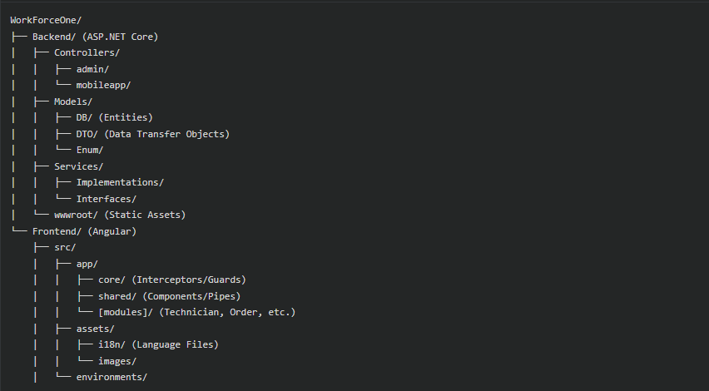
2. Naming Conventions:
- Use PascalCase for backend classes, methods, and C# files (e.g., ServiceTask.cs).
- Use camelCase for frontend variables, functions, and TypeScript properties.
- Use kebab-case for Angular file names and selectors (e.g., technician-list.component.ts).
- Use clear and descriptive names for variables and methods (e.g., getServiceTasks() instead of getData()).

3. Code Formatting & Best Practices:
- Follow official Microsoft C# Coding Conventions and Angular Style Guide.
- Use Dependency Injection (DI) for better testability and maintainability.
- Utilize AutoMapper for efficient mapping between entities and DTOs.
- Keep components small, reusable, and modular across the application.
- Implement Internationalization (i18n) for supporting multiple languages.

4. Error Handling:
- Wrap database operations and API calls inside try-catch blocks.
- Use Global Exception Middleware for handling unhandled errors and returning consistent responses.
- Provide user-friendly feedback using alerts or toast notifications.
- Handle null values safely using C# nullable types and TypeScript optional chaining.

5. UI & Performance Optimization:
- Design responsive layouts for mobile, tablet, and desktop screens.
- Optimize large data sets (e.g., technician lists, orders) using efficient grid systems.
- Use Lazy Loading in Angular to improve initial load performance.
- Apply animations carefully to enhance UI without affecting performance.

6. Version Control:
- Use Git for source code management.
- Maintain clear and meaningful commit messages (e.g., feat: add task auto-cancellation logic).
- Use .gitignore to exclude sensitive files and unnecessary build artifacts.

4.2 Screen Shots
Admin:
1. Dashboard

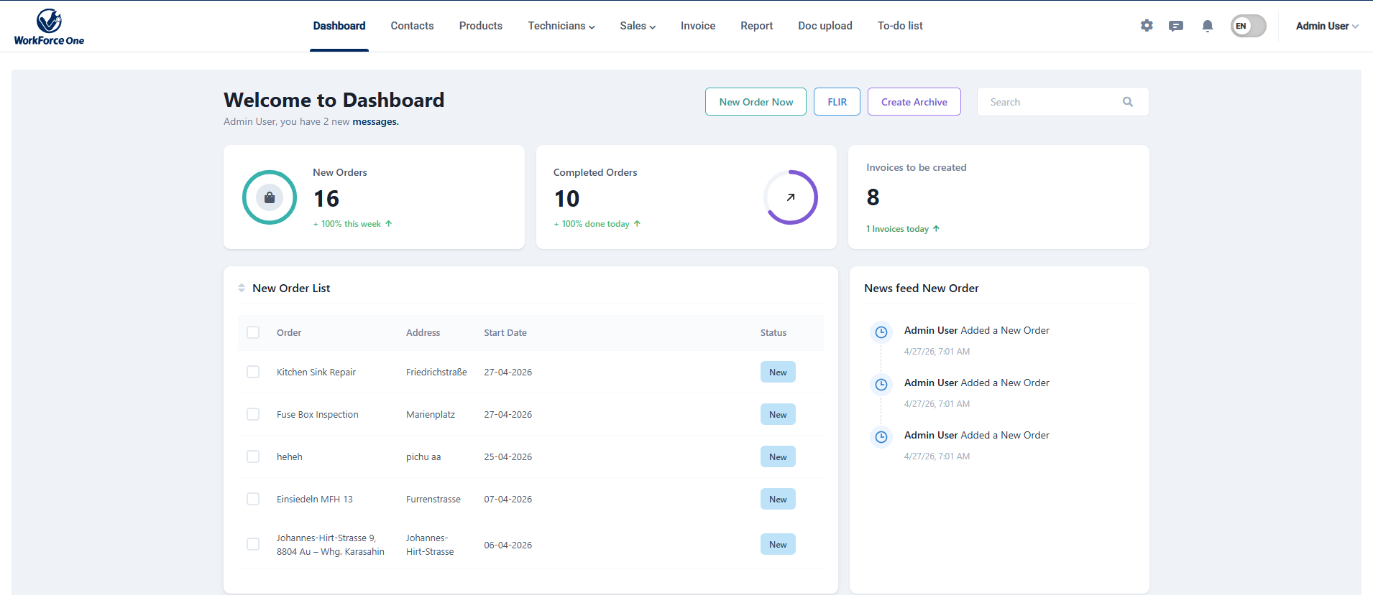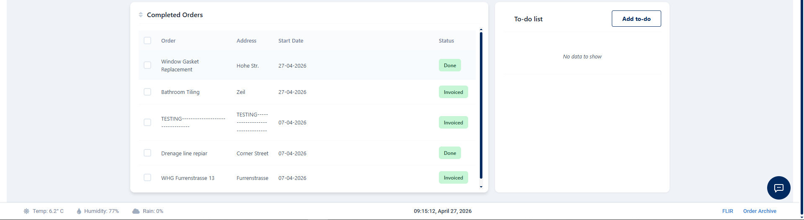

2. Add Contact :

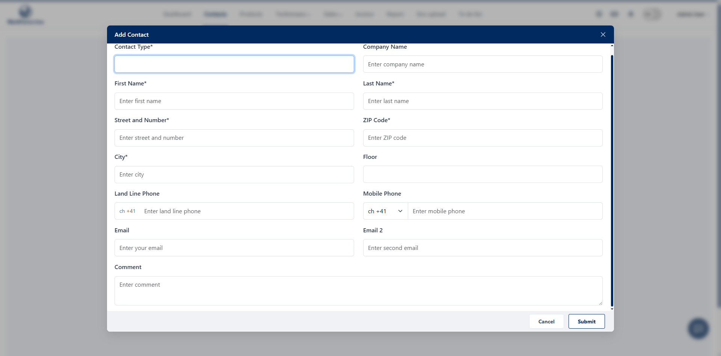
3. Add Category:

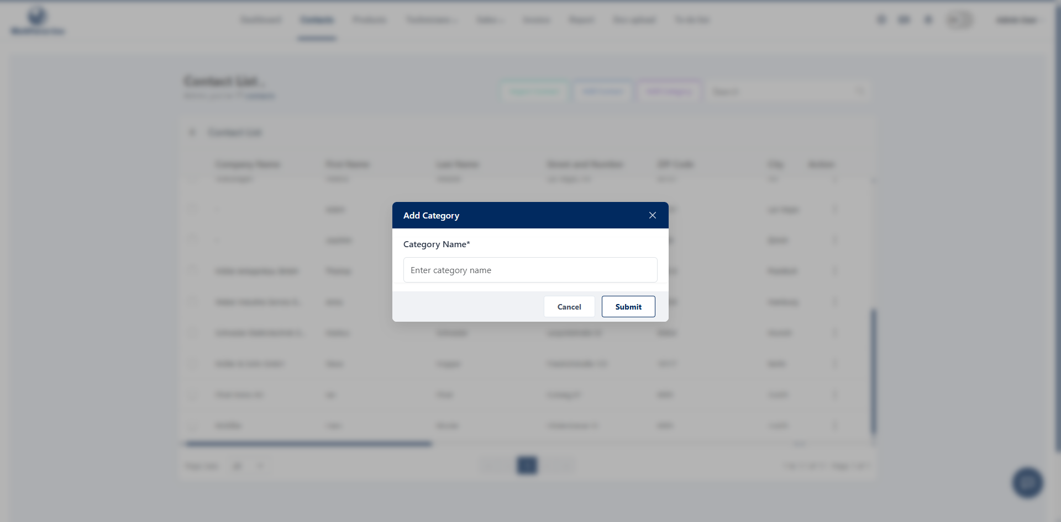
4. Contact List:

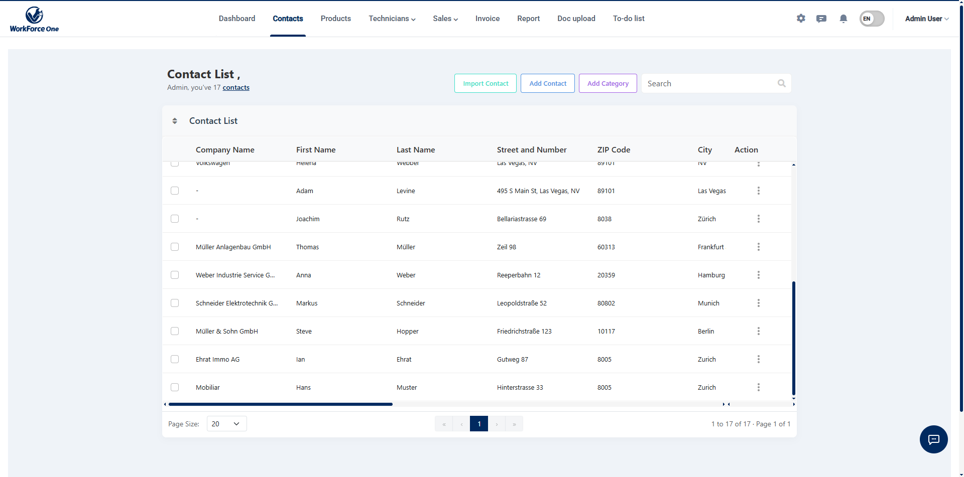

5. Add Product:

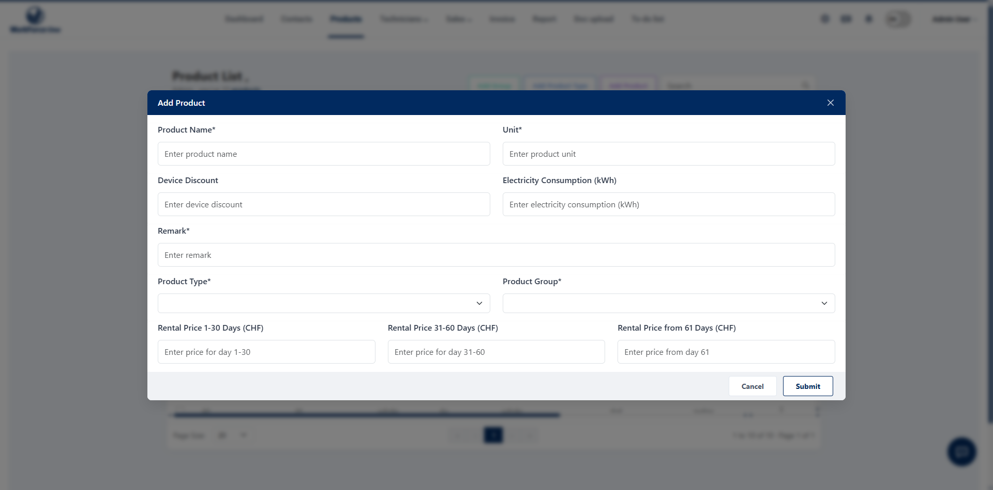

6. Add Product Type:

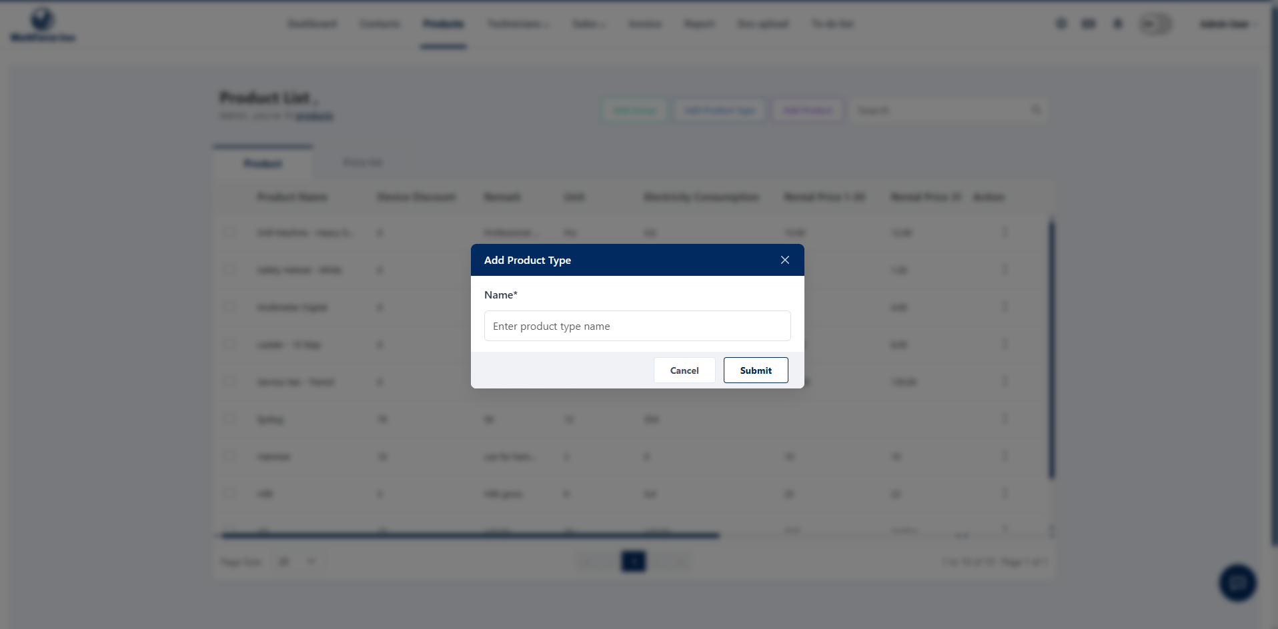

7. Add Product Group:

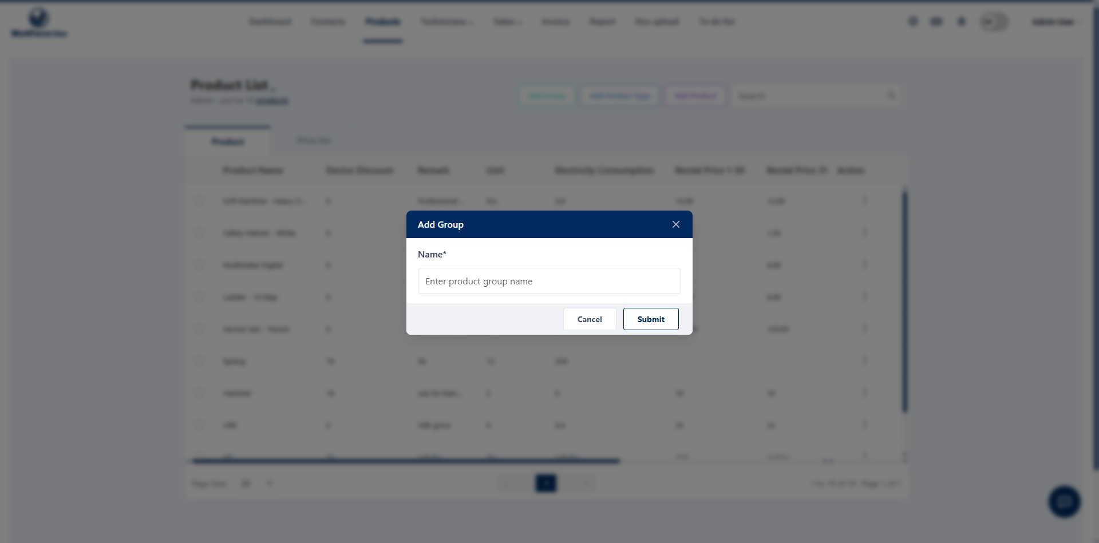

8. Product List

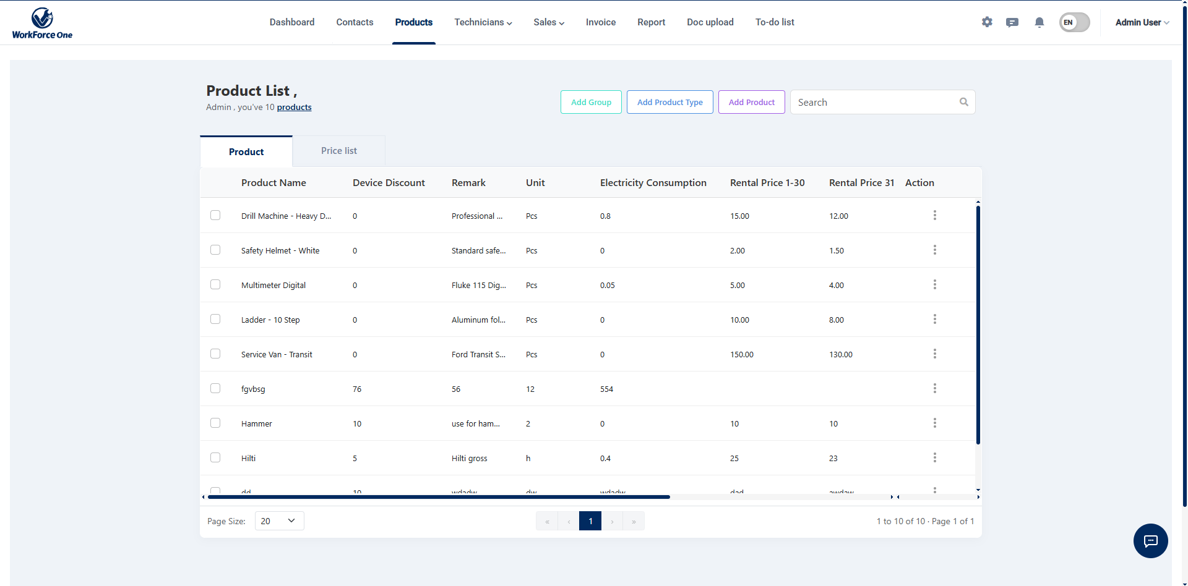

9. Add Technician:

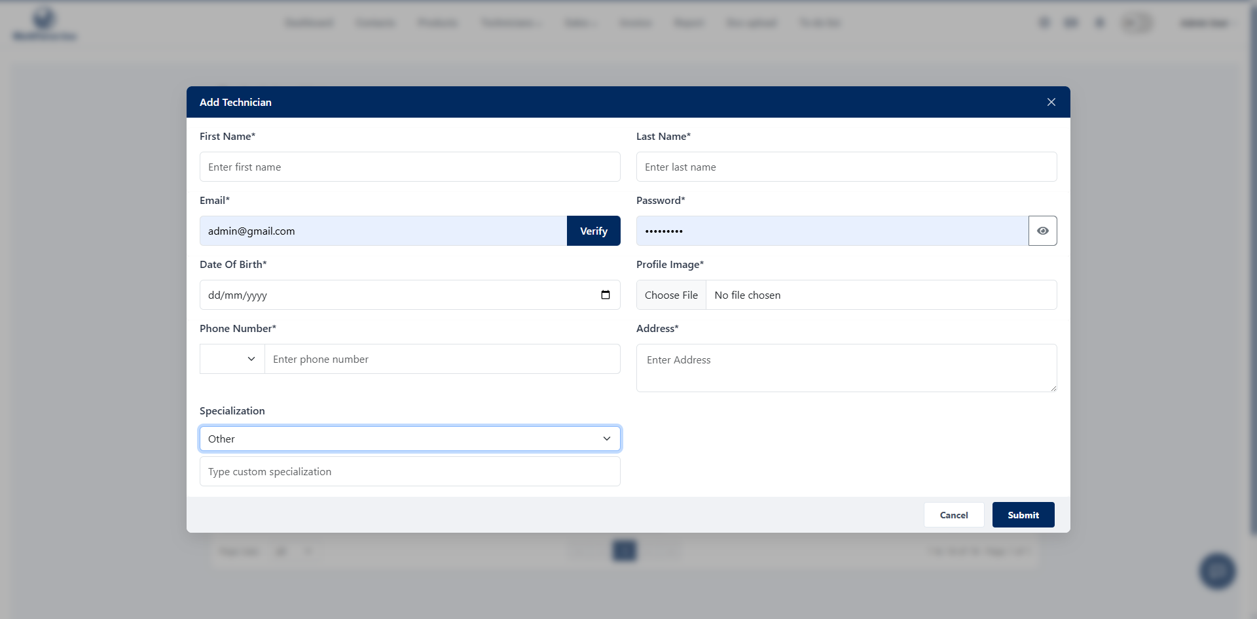

10. Technician List:

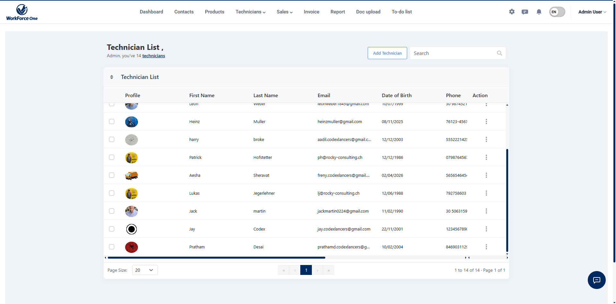

11. Technician Workload:

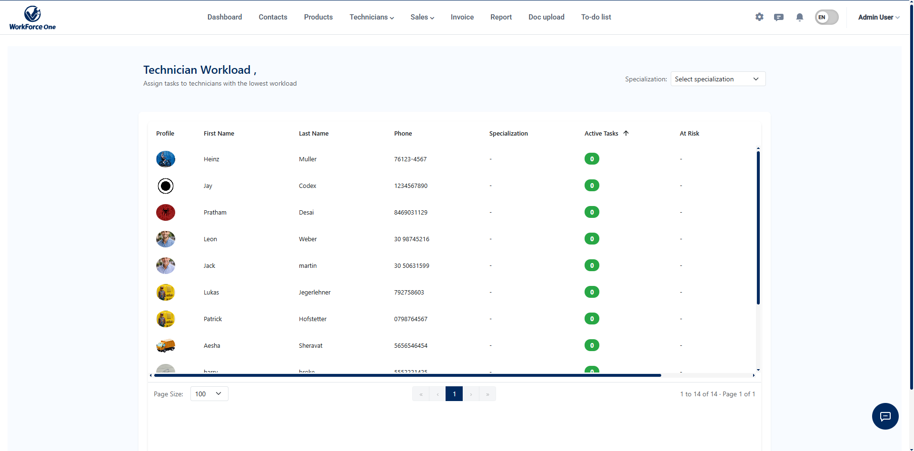

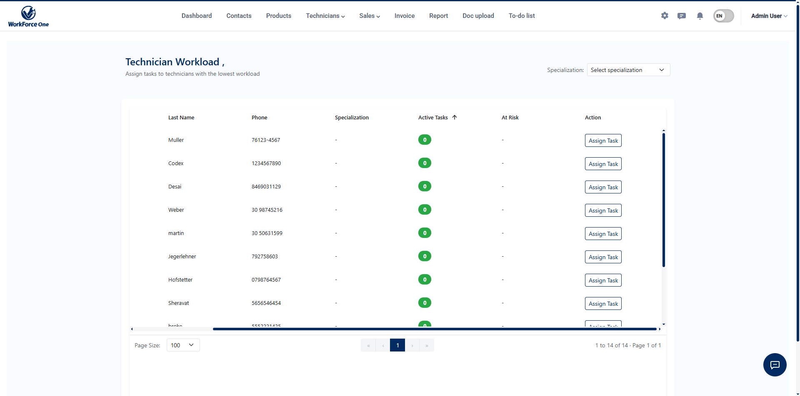

12. Offers List:

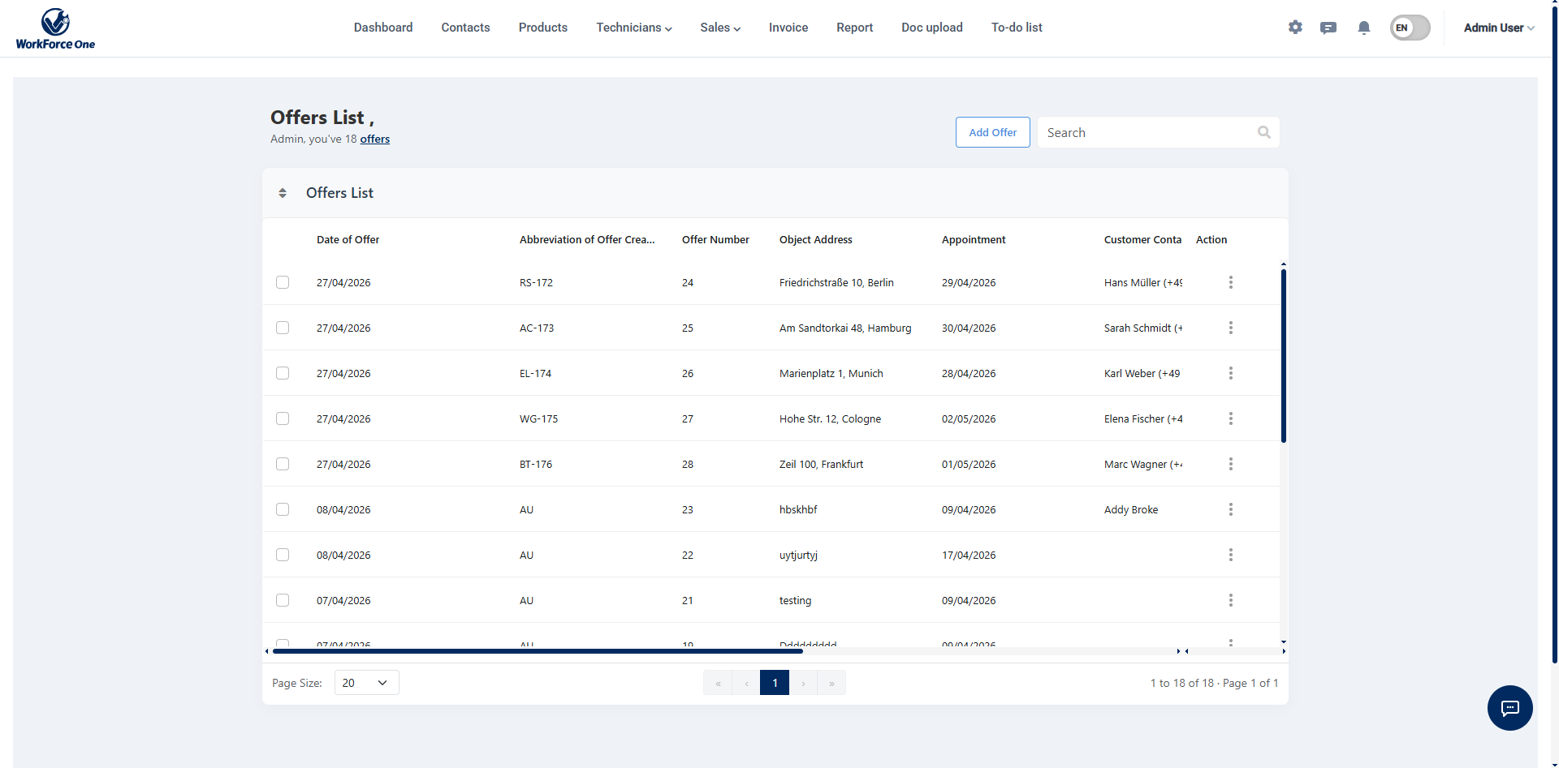

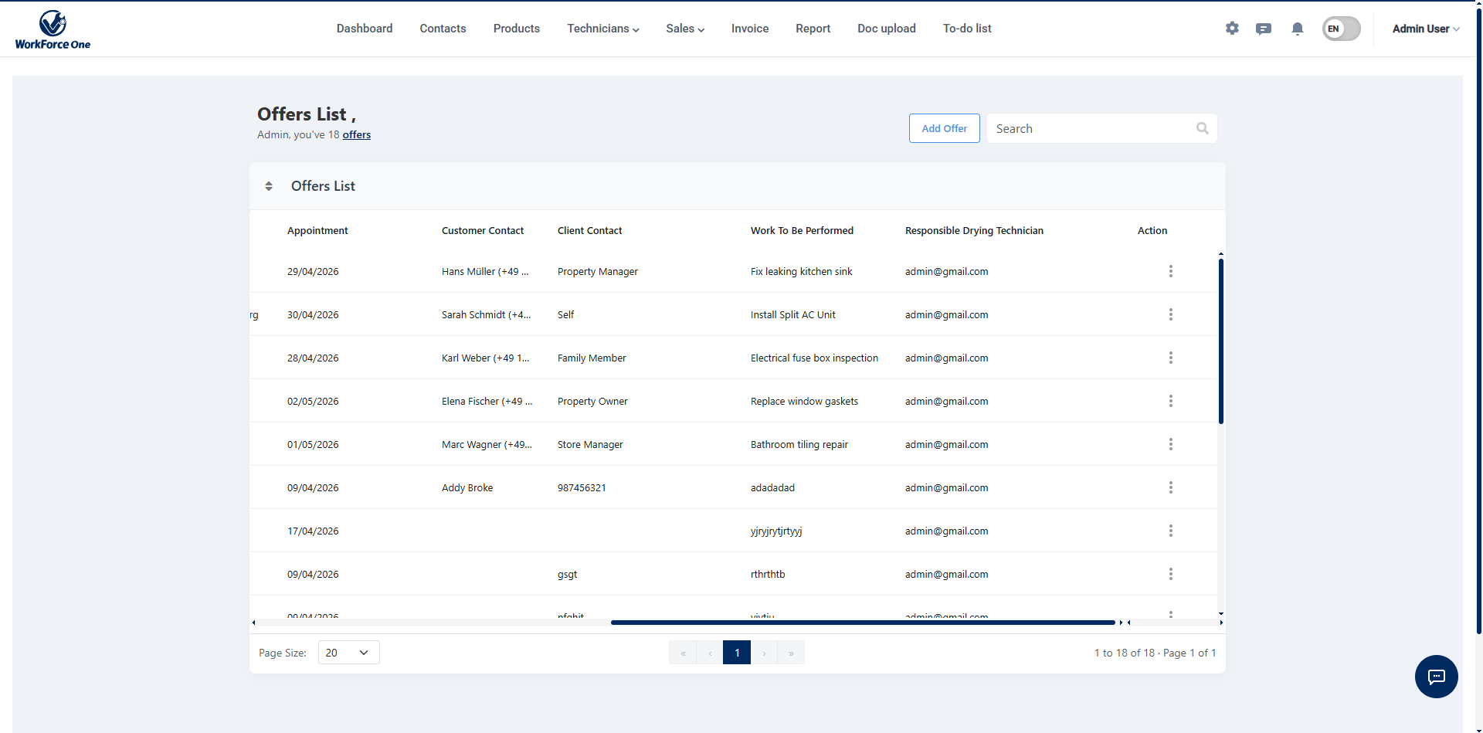

13. Add Order:

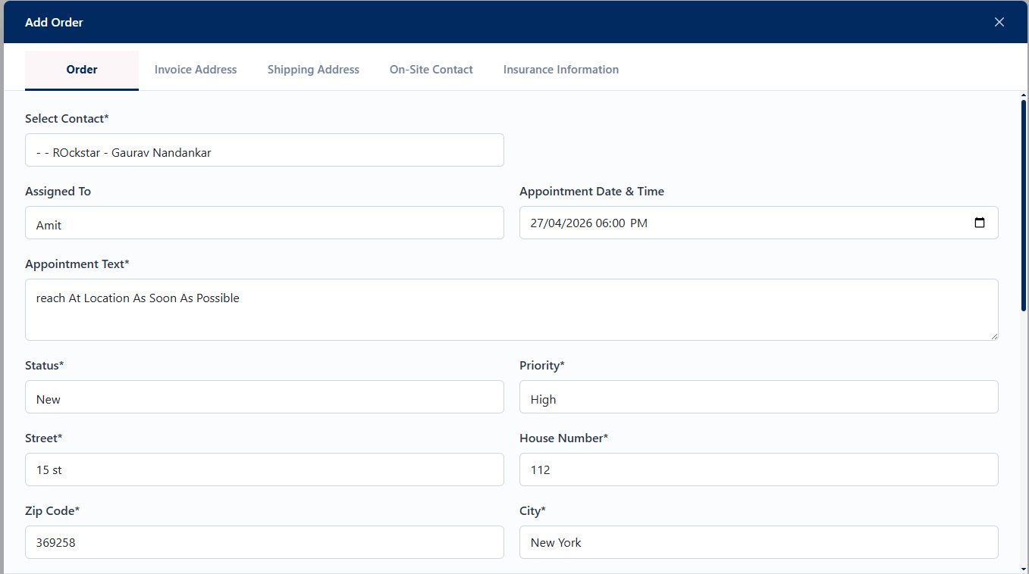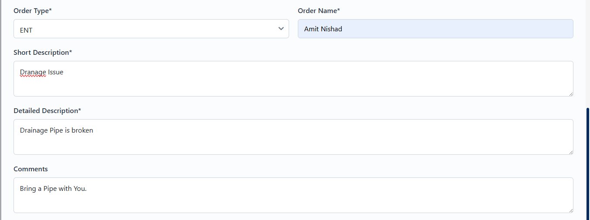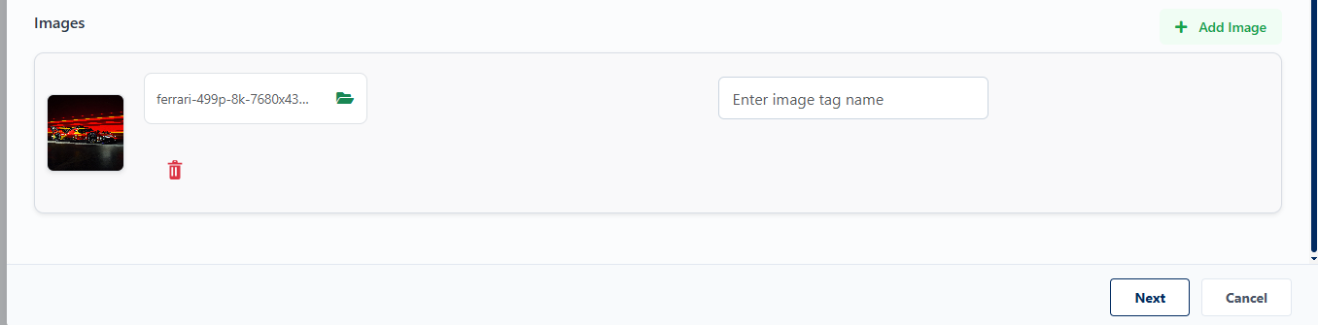
14. Add Order –Invoice Address:

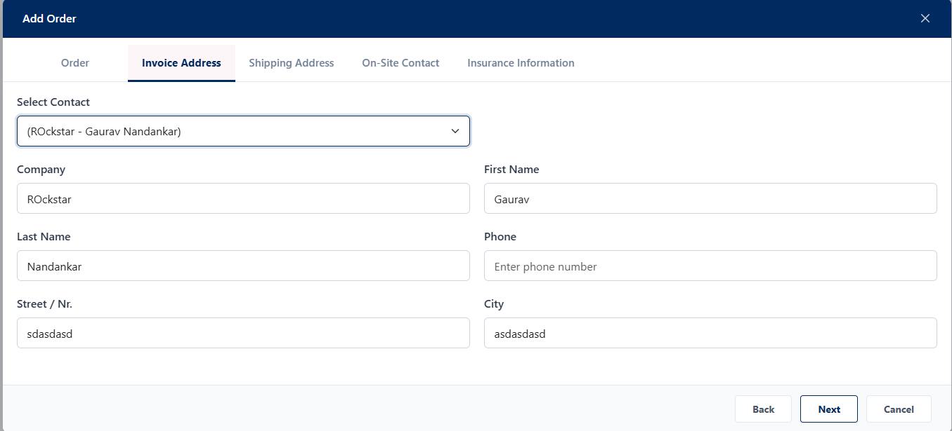
15. Add Order – Shipping Address:

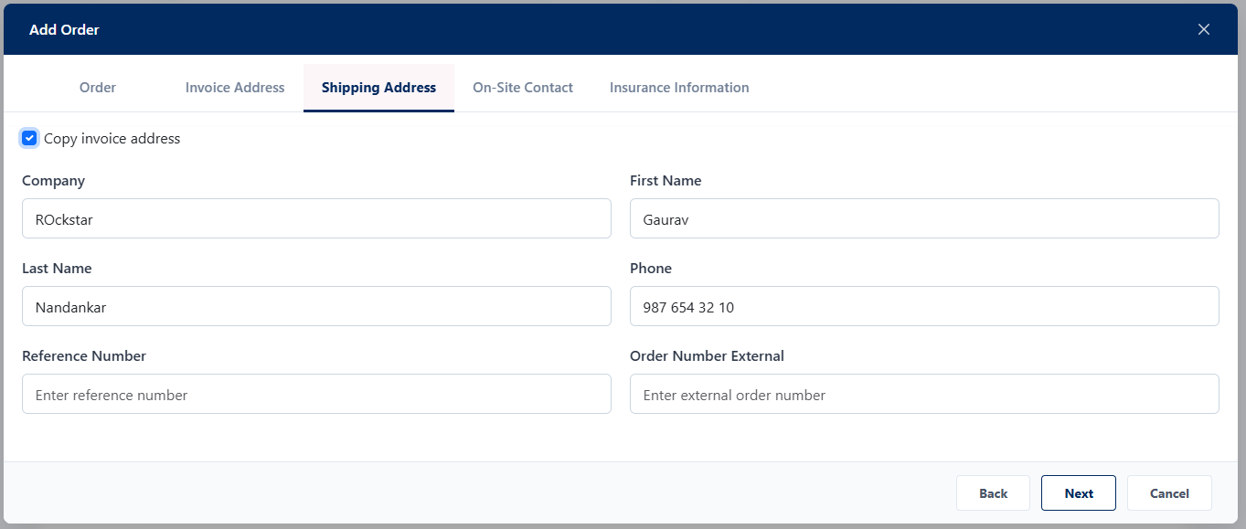

16. Add Order – On Site Contact:

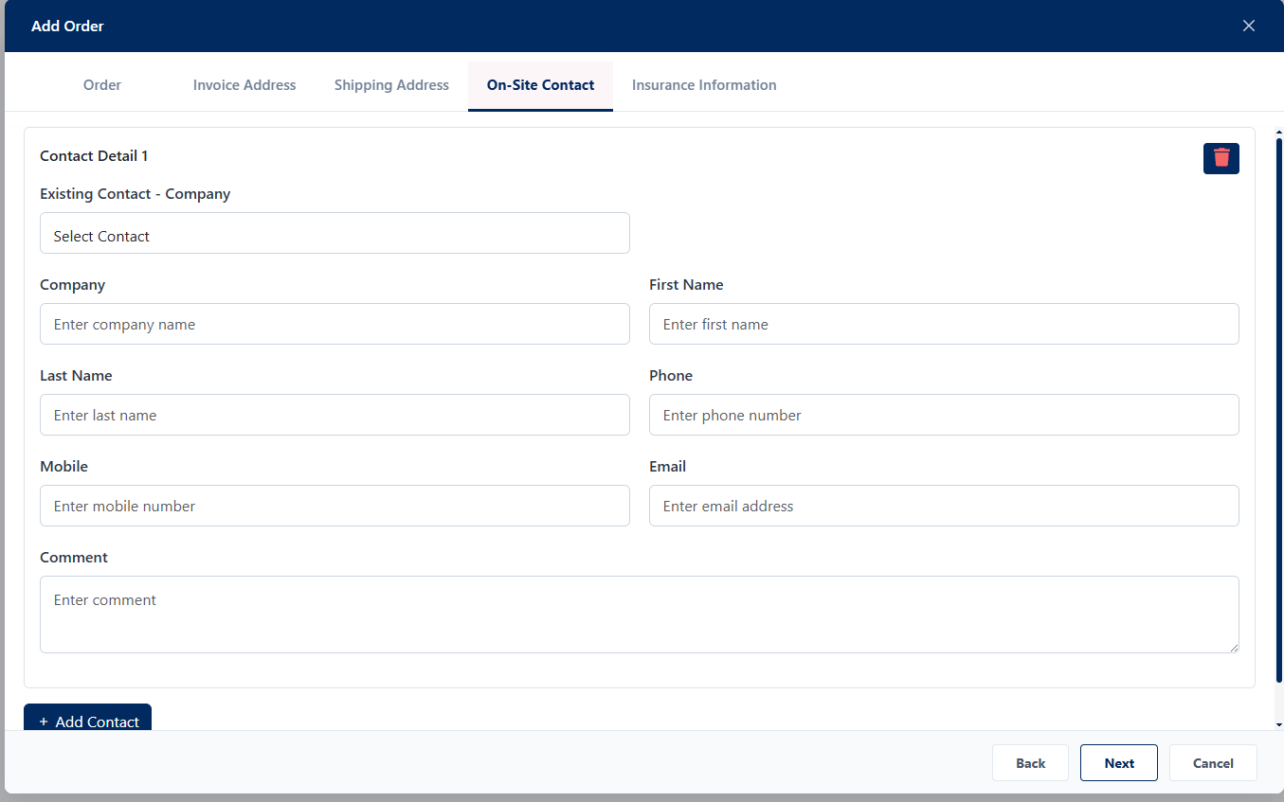

17. Add Order – Insurance Information:

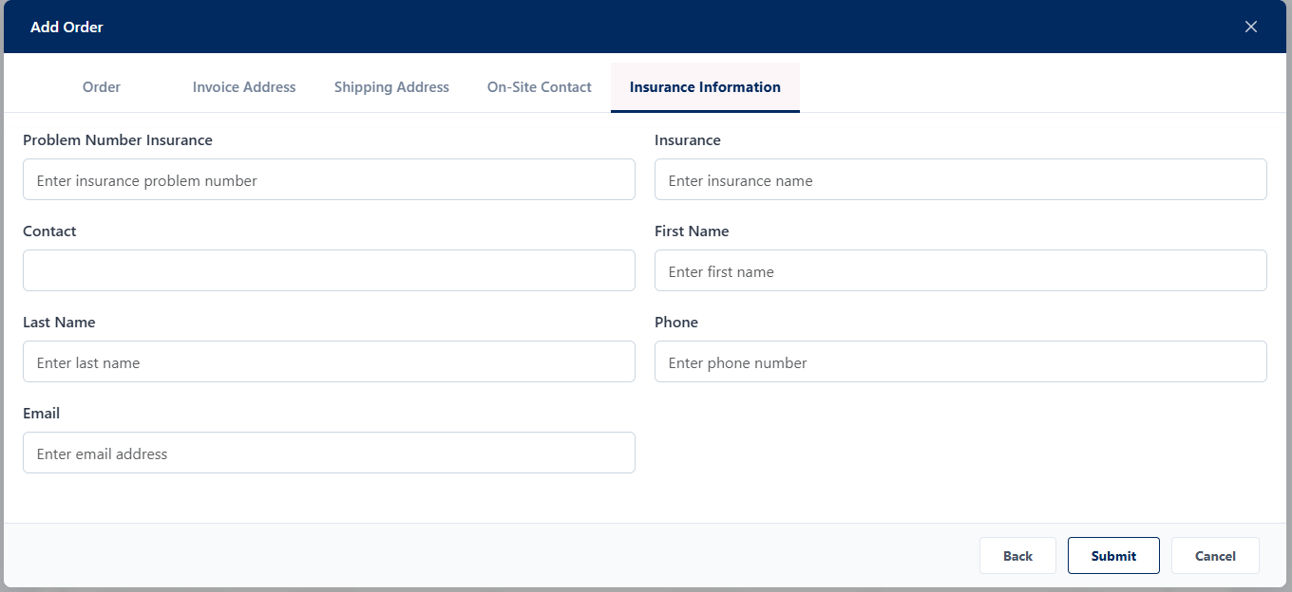

18. Add Order – On Site Contact:



19. Add Order – Insurance Information:



20. Add Order – Filter Order and Media:

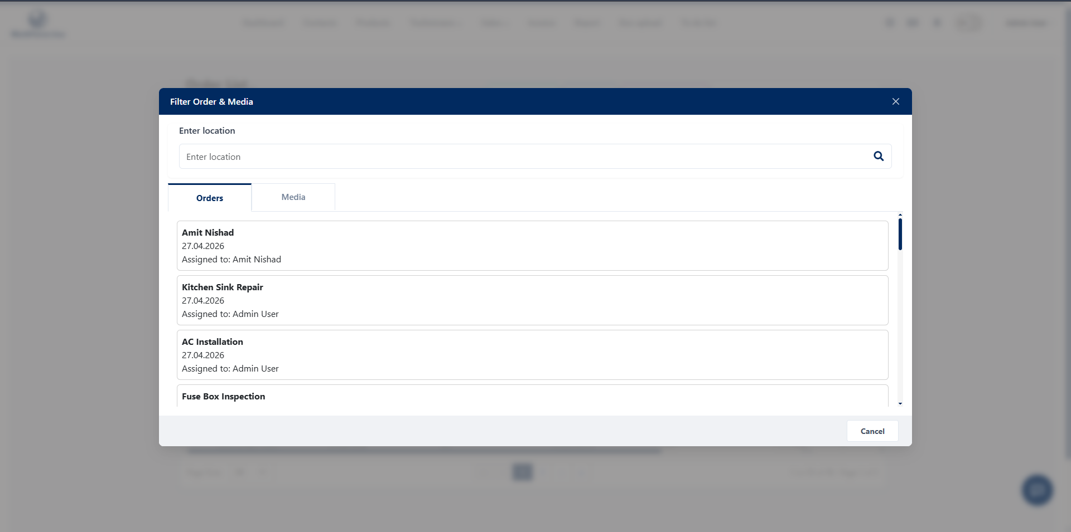

21. Invoice – Manual Entry:

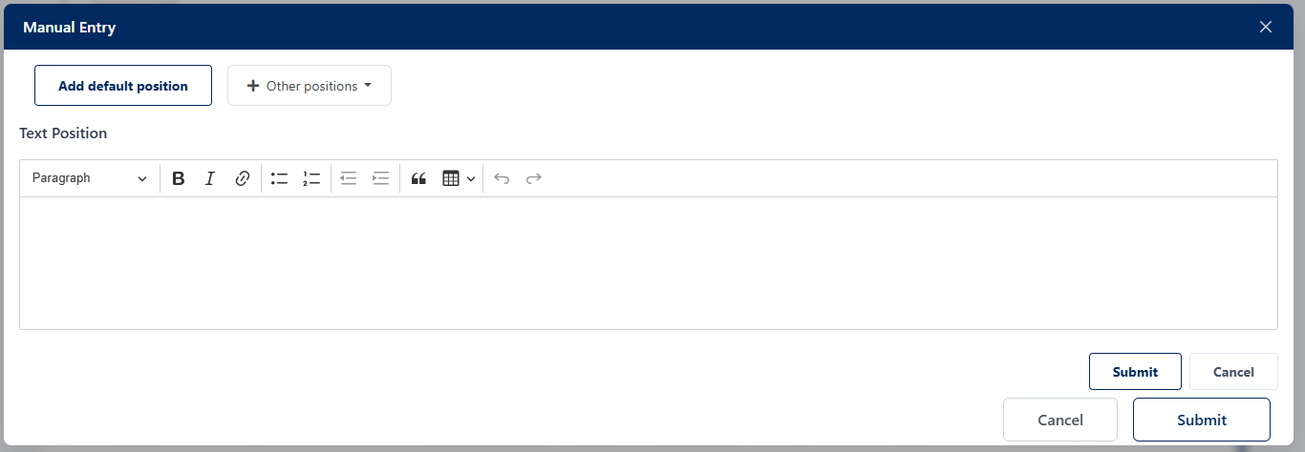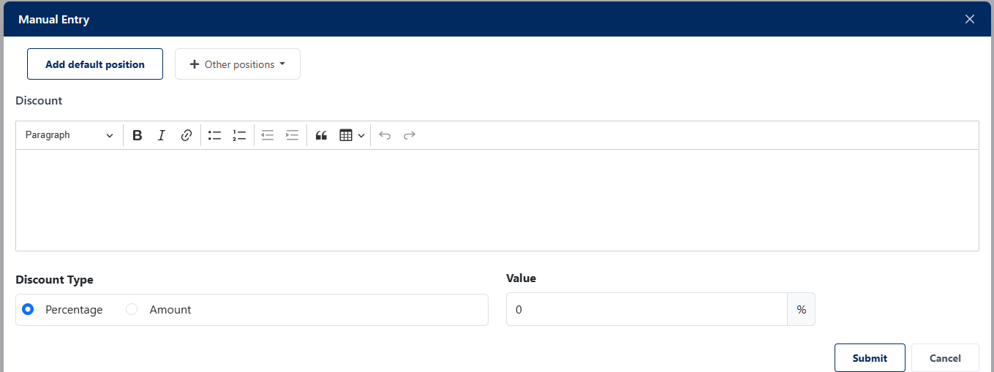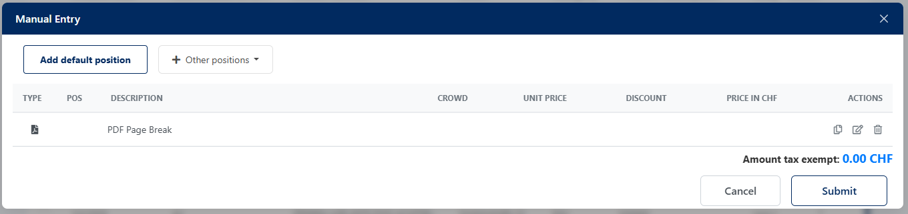

22. Invoice List:

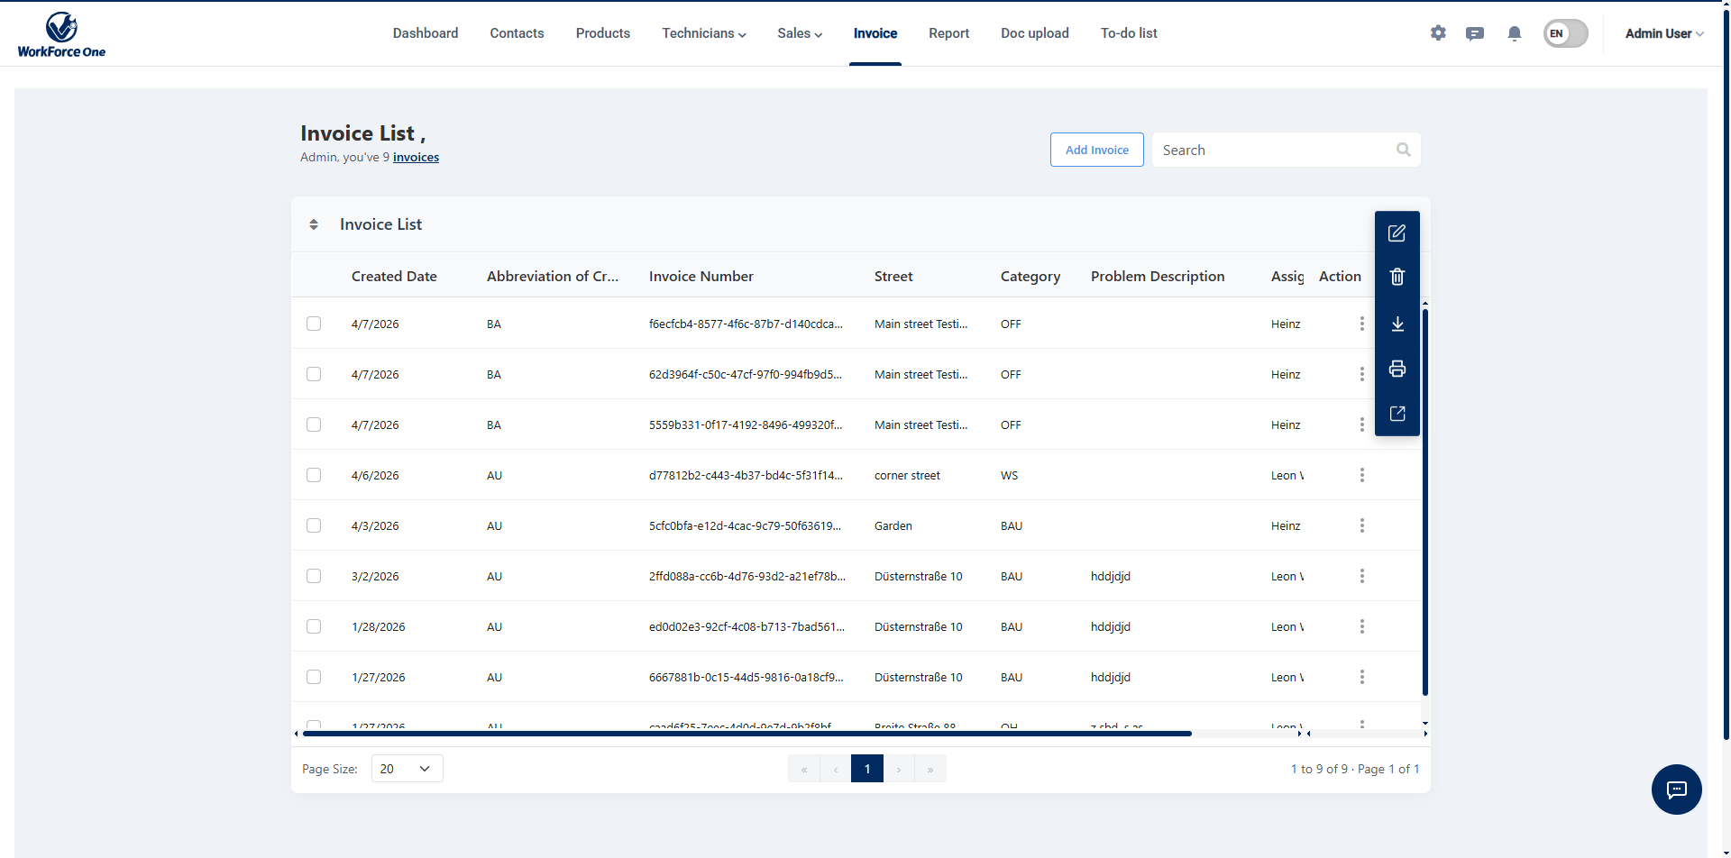
23. Report List:

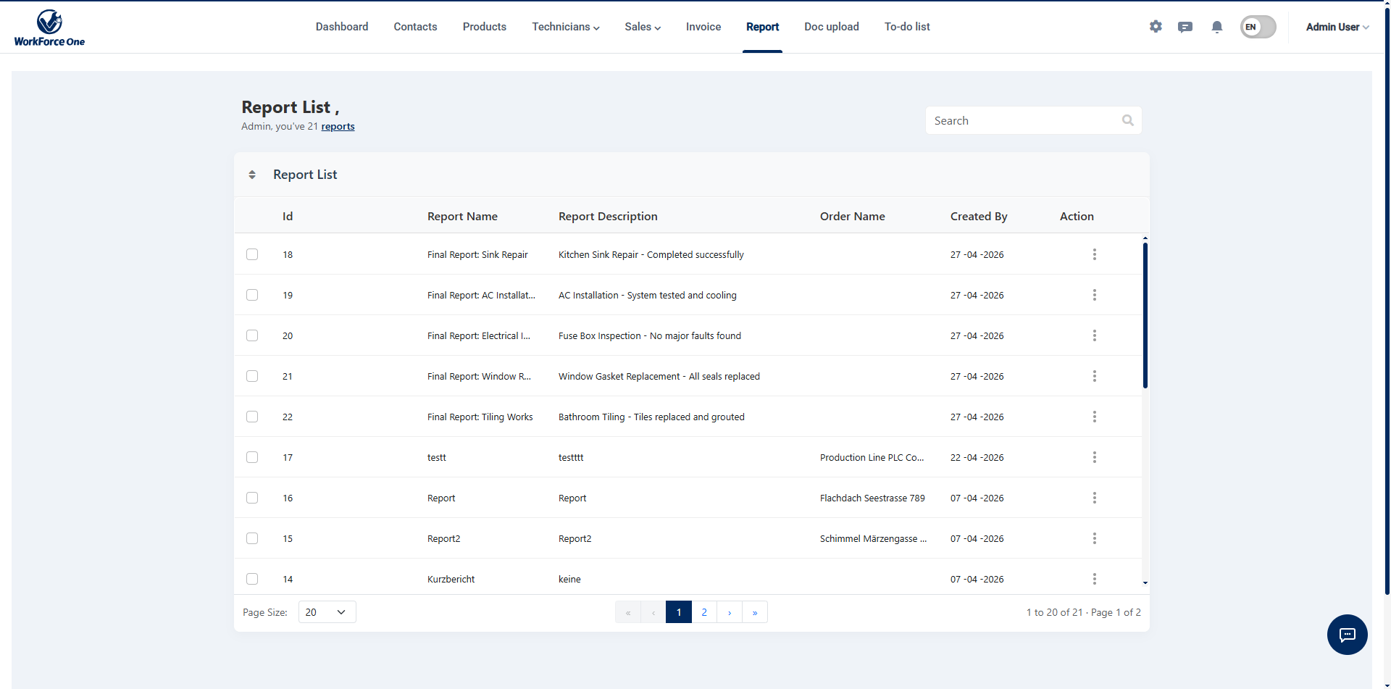

24. Documents Upload:

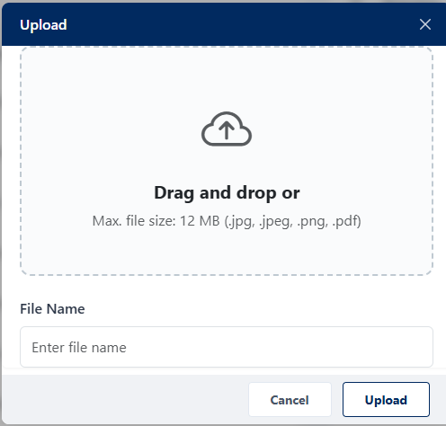
25. Documents Upload – Assign Media:

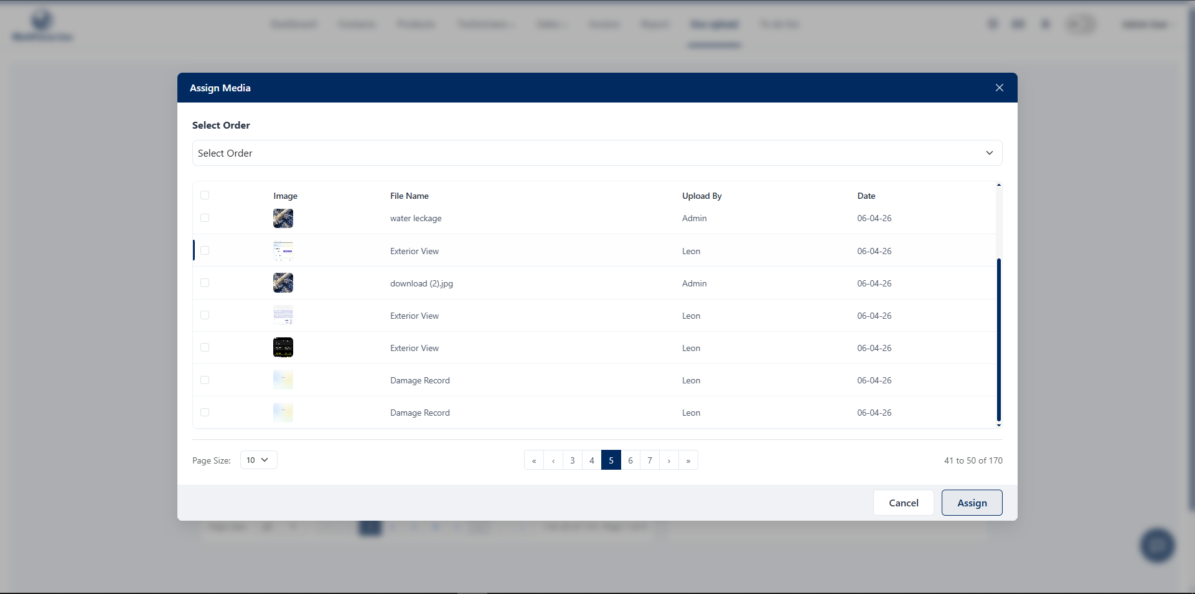

26. Document Upload – List:

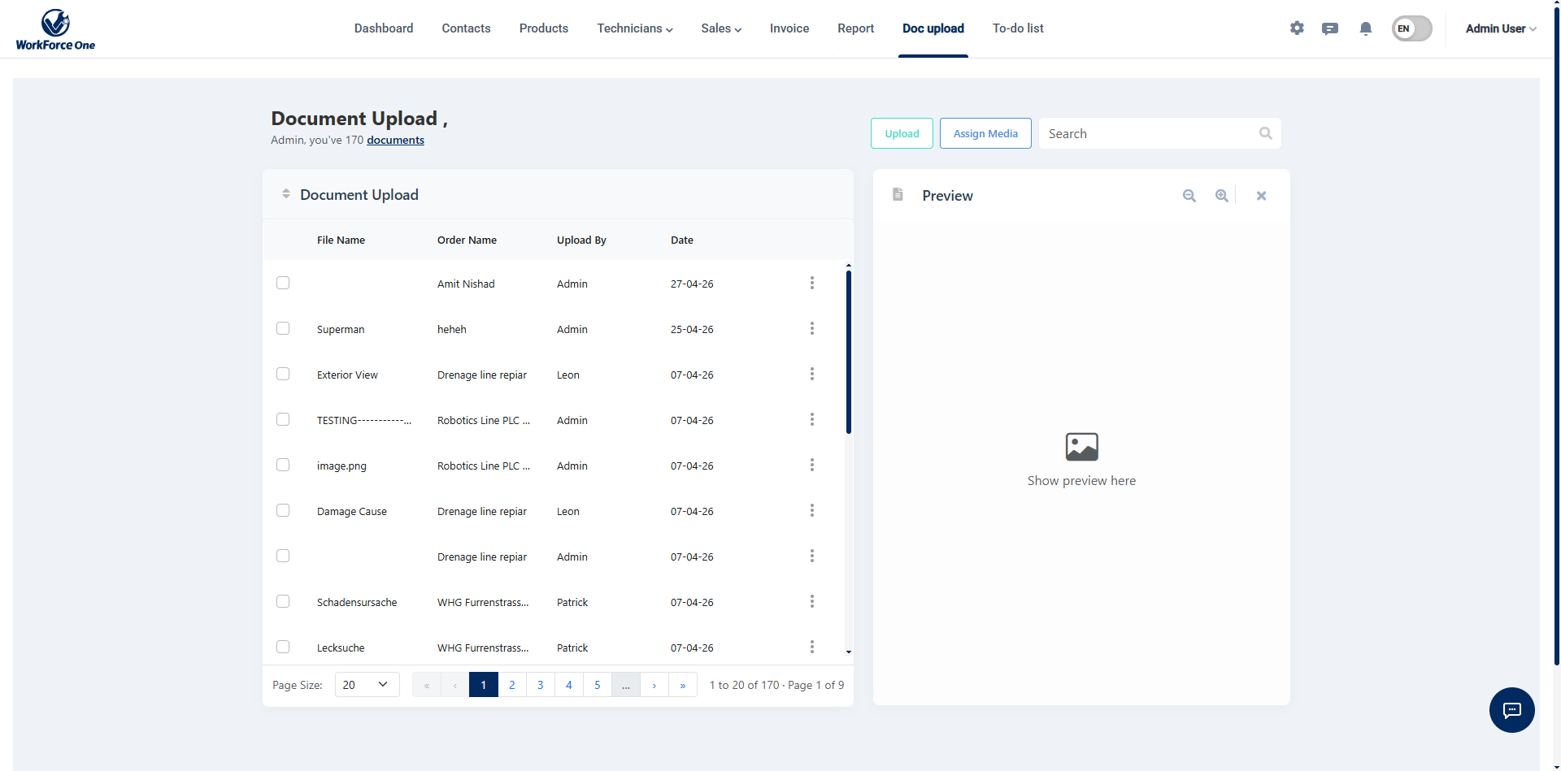

27. To-Do List:

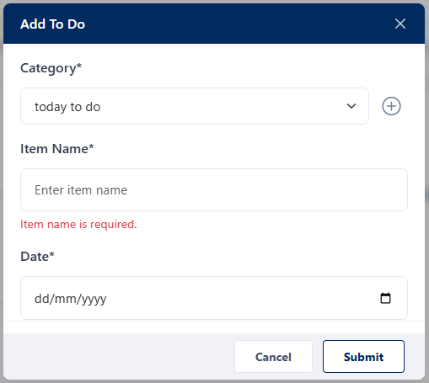

28. To-Do List:

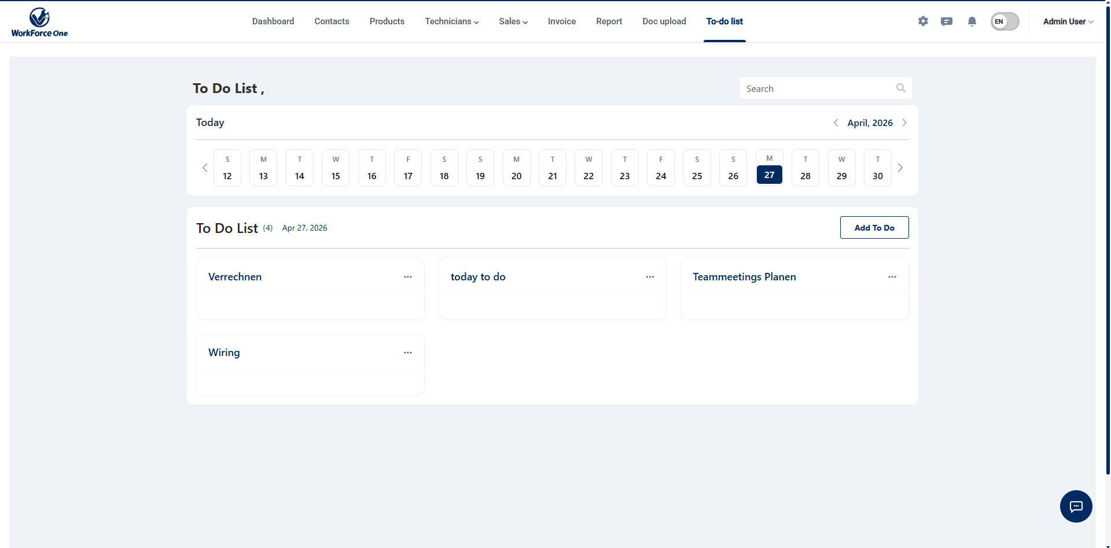

29. Profile:

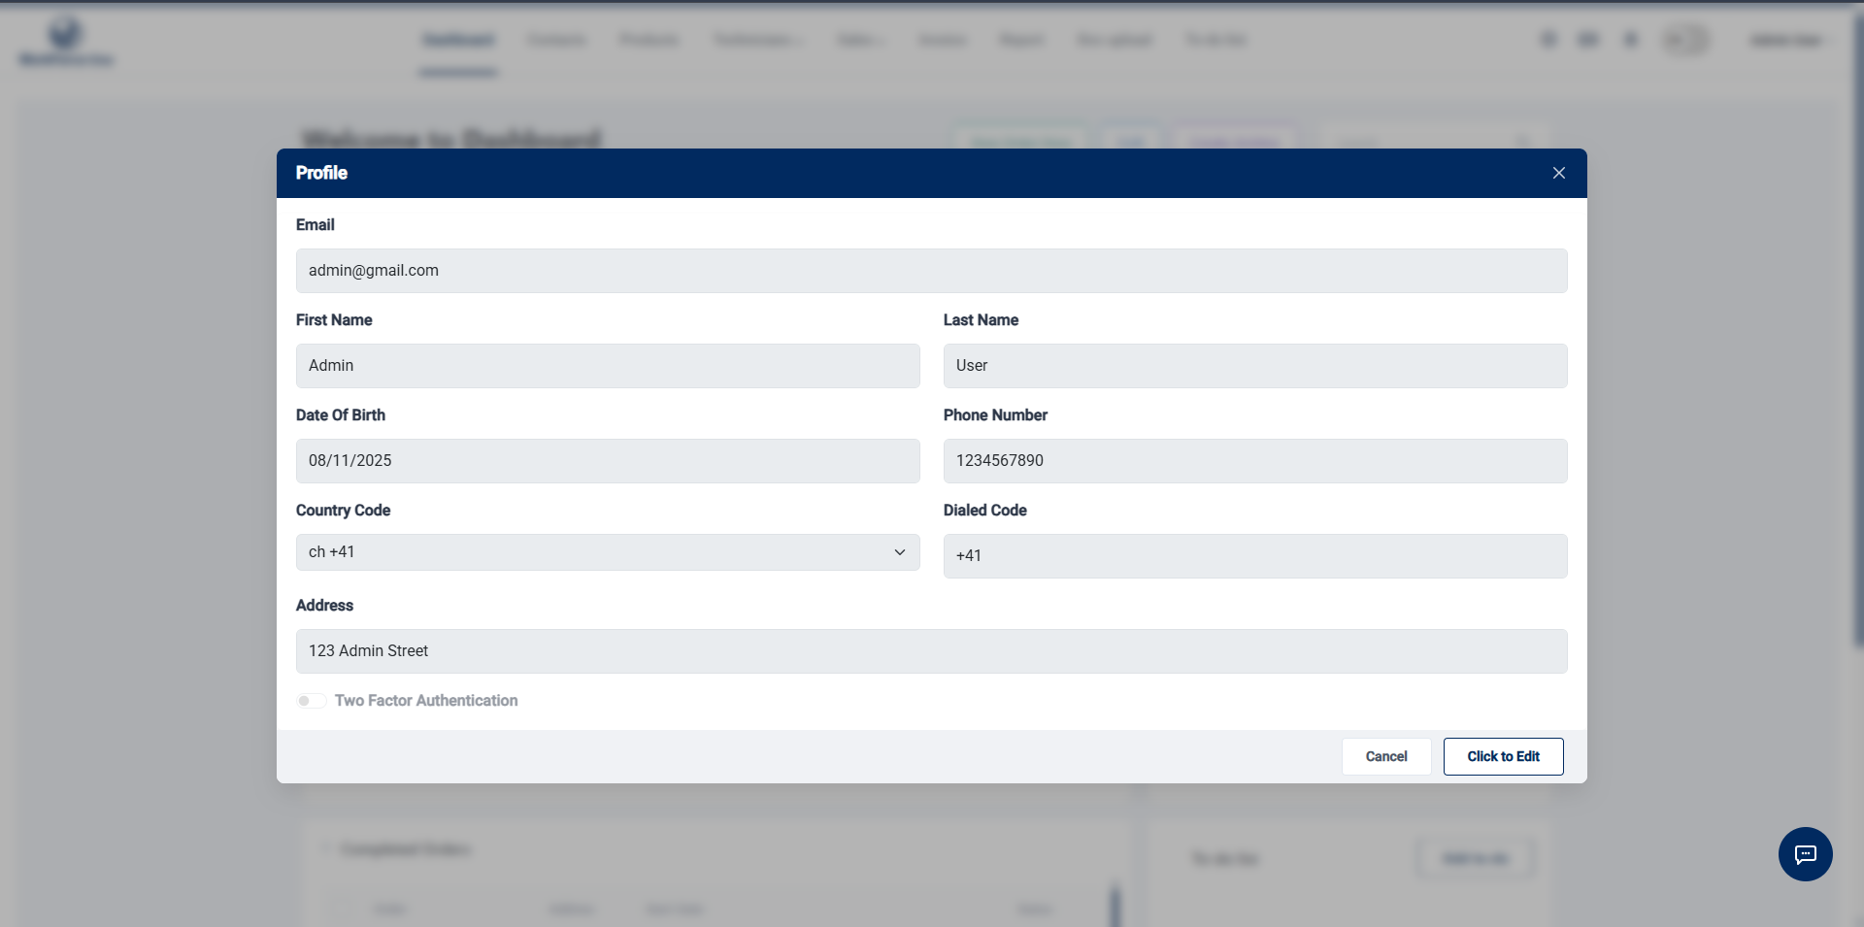

5. Agile Documentation
5.1 Agile Project Charter

Project Title | WorkForce One
Project Start Date | 01 January, 2026
Project End Date | 30 April, 2026
Project Scope | WorkForce One is a field-service management platform that connects administrative staff and field technicians through structured digital workflows.  The system includes task assignment, real-time job tracking, media uploads, automated reporting, and invoice generation through a web portal and mobile application.
Objectives | - Enable efficient task creation, assignment, and tracking between admin and field teams.  - Provide real-time updates and media uploads from technicians in the field.  - Automate service report and invoice generation to reduce manual work.  - Ensure secure role-based access for admins and technicians.  - Maintain centralized data for customers, products, and service history.
Roles Involved | - Product Owner  - Angular Developer (Web Admin Portal)  - Backend Developer (.NET)  - Mobile App Developer  - UI/UX Designer
Key Stakeholders | - End Users (Admins & Technicians)  - Business Owner  - Development Team (Developers, Designers, Testers)  - Clients/Service Consumers

5.2 Agile Roadmap / Schedule

Id | Task Name | Start Date | End Date
1 | Project Planning & Research | 01 Jan, 2026 | 05 Jan, 2026
2 | Requirement Gathering | 06 Jan, 2026 | 10 Jan, 2026
3 | UI/UX Design | 11 Jan, 2026 | 17 Jan, 2026
4 | Database Design & Setup | 18 Jan, 2026 | 24 Jan, 2026
5 | Backend Development | 25 Jan, 2026 | 10 Feb, 2026
6 | Frontend Development | 11 Feb, 2026 | 25 Feb, 2026
7 | API Integration | 26 Feb, 2026 | 05 Mar, 2026
8 | Testing & Debugging | 06 Mar, 2026 | 15 Mar, 2026
9 | Deployment & Optimization | 16 Mar, 2026 | 22 Mar, 2026
10 | User Acceptance Testing | 23 Mar, 2026 | 05 Apr, 2026
11 | Final Review & Enhancements | 06 Apr, 2026 | 15 Apr, 2026
12 | Project Submission & Closure | 30 Apr, 2026 | 30 Apr, 2026

5.3 Agile Project Plan

Sprint | Task Name | Start Date | End Date | Days
Sprint 1 | Project Planning & Research | 01-Jan-2026 | 05-Jan-2026 | 5
 | Requirement Gathering | 06-Jan-2026 | 10-Jan-2026 | 5
 | UI/UX Design | 11-Jan-2026 | 17-Jan-2026 | 7
Sprint 2 | Database Design & Setup | 18-Jan-2026 | 24-Jan-2026 | 7
 | Backend Development | 25-Jan-2026 | 10-Feb-2026 | 17
Sprint 3 | Frontend Development | 11-Feb-2026 | 25-Feb-2026 | 15
 | API Integration | 26-Feb-2026 | 05-Mar-2026 | 8
Sprint 4 | Testing & Debugging | 06-Mar-2026 | 15-Mar-2026 | 10
 | Deployment & Optimization | 16-Mar-2026 | 22-Mar-2026 | 7
 | User Acceptance Testing | 23-Mar-2026 | 05-Apr-2026 | 14
Sprint 5 | Final Review & Enhancements | 06-Apr-2026 | 15-Apr-2026 | 10
 | Project Submission & Closure | 30-Apr-2026 | 30-Apr-2026 | 1

5.4 Agile User Story

Case | As a User | I want to | So that I can
1 | Admin | Create and assign service tasks. | Ensure technicians receive jobs quickly and efficiently.
2 | Technician | View assigned tasks. | Know what work needs to be done and manage my schedule.
3 | Technician | Update task status. | Inform admins about job progress in real time.
4 | Technician | Upload photos and notes | Provide proof of completed work and proper documentation.
5 | Admin | Generate invoices and reports | Complete billing and maintain service records easily.

5.5 Agile Release Plan

Release | Sprint | Start Date | End Date | Features / Tasks | Status
Release 1 | Sprint 1 | 01-Jan-2026 | 17-Jan-2026 | Planning, Research, UI/UX Design | Completed
Release 2 | Sprint 2 | 18-Jan-2026 | 10-Feb-2026 | Backend & Database Setup | Completed
Release 3 | Sprint 3 | 11-Feb-2026 | 05-Mar-2026 | Frontend Development, API Integration | Completed
Release 4 | Sprint 4 | 06-Mar-2026 | 05-Apr-2026 | Testing, Deployment, User Testing | Completed
Release 5 | Sprint 5 | 06-Apr-2026 | 30-Apr-2026 | Final Enhancements & Submission | Completed

5.6 Agile Sprint Backlog

Sprint | Task ID | Task Name | Assigned To | Status | Priority
Sprint 1 | T1 | Project Planning & Research | Product Owner | Completed | High
Sprint 2 | T2 | Backend Development | Backend Developer (.NET) | Completed | High
Sprint 3 | T3 | Frontend Development & API Integration | Angular Developer | Completed | High
Sprint 4 | T4 | Testing & Debugging | QA Engineer | Completed | High

5.7 Agile Test Plan
Testing Phase:
- Unit Testing: Tests individual components such as authentication, task creation, job assignment, and invoice generation.
- Integration Testing: Ensures proper data flow between the Angular frontend, ASP.NET Core backend, database, and services like media upload and PDF generation.
- System Testing: Verifies complete workflows, including task assignment, technician execution, media uploads, and report/invoice generation.
- User Acceptance Testing: Confirms that the system meets user requirements and provides a smooth experience for both admins and technicians.
- Performance Testing: Evaluates system responsiveness, handling of multiple tasks, and performance under high data loads.
- Security Testing: Ensures secure authentication (JWT), data protection, and prevention of unauthorized access.
Test Cases:
Test ID | Test Scenario | Expected Result | Sprint
1 | Validate user authentication using JWT | Users (Admin/Technician) should be able to log in securely | Sprint 1
2 | Verify role-based access control | Admins and Technicians should only access their respective features | Sprint 1
3 | Test task creation and assignment | Admin should be able to create and assign tasks successfully | Sprint 2
4 | Ensure real-time task updates by technicians | Task status should update instantly (in-progress/completed) | Sprint 3
5 | Validate media upload (photos/documents) | Technicians should upload images successfully linked to tasks | Sprint 3
6 | Check invoice and report generation | System should generate accurate reports and invoices after task completion | Sprint 4

5.8 Earned – value and burn charts
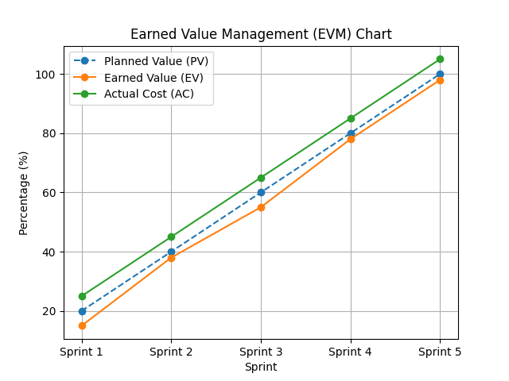
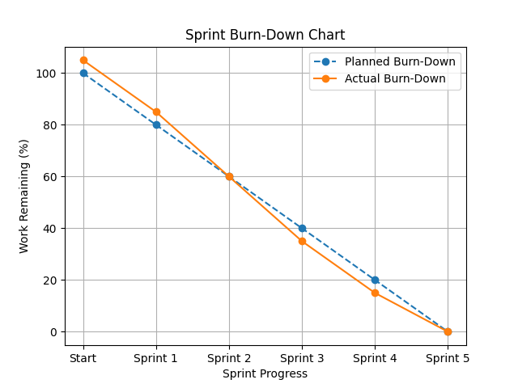
6. Proposed Enhancements
While the current version of WorkForce One provides a strong foundation for managing field technicians and service operations, several advanced enhancements can be implemented in the future to further improve efficiency, automation, and user experience:

- AI-Driven Predictive Maintenance: By leveraging machine learning algorithms on historical service data, the system can predict potential equipment failures in advance. This enables proactive maintenance scheduling, reducing downtime and improving service reliability.
- Intelligent Route Optimization: Integration with mapping services such as Google Maps Matrix API can help calculate the most efficient travel routes for technicians based on real-time traffic conditions. This will minimize travel time, reduce fuel consumption, and improve overall productivity.
- Offline Synchronization Capability: Implementing an offline-first approach using local storage technologies (such as SQLite or IndexedDB) will allow technicians to continue working in low or no network areas. Data can be automatically synchronized once connectivity is restored, ensuring uninterrupted workflow.
- Customer Service Portal: A dedicated web portal for customers can provide real-time tracking of service requests, technician arrival estimates, and digital acknowledgment of completed work. This enhances transparency and improves customer satisfaction.
- IoT Integration for Smart Service Triggers: Connecting the platform with IoT-enabled devices can allow automatic generation of service tasks when predefined conditions (such as temperature or pressure thresholds) are exceeded, enabling faster response and preventive maintenance.

These enhancements will transform WorkForce One into a more intelligent, scalable, and future-ready platform, capable of delivering highly efficient and automated field-service management.

7. Conclusion
WorkForce One is a transformative field-service management platform designed to bridge the gap between administrative teams and field technicians through seamless digital workflows. By centralizing operations within a unified ASP.NET Core and Angular-based system, the platform ensures efficient task coordination, real-time tracking, and structured service management.
The inclusion of features such as a real-time workload dashboard, automated task handling, and instant notifications through Firebase Cloud Messaging (FCM) significantly enhances operational efficiency and communication. Administrators gain better control over task distribution and monitoring, while technicians benefit from clear task visibility and streamlined execution, reducing delays and confusion in the field.
With a scalable and modular architecture built on clean coding principles and repository patterns, WorkForce One is well-equipped to support growing business demands, including multiple tenants and a large workforce. As a result, the platform delivers a reliable, efficient, and modern solution for field-service management, ensuring improved productivity, data integrity, and overall operational excellence.

8. Bibliography
References:
- Angular Documentation. (2024). The modern web developer's platform. Retrieved from
  - https://angular.dev/
- Microsoft Corporation. (2024). ASP.NET Core Documentation. Retrieved from
  - https://learn.microsoft.com/en-us/aspnet/core/
- Google Firebase. (2024). Firebase Cloud Messaging (FCM) Documentation. Retrieved from
  - https://firebase.google.com/docs/cloud-messaging
- Ag-Grid Ltd. (2024). Ag-Grid: The Best JavaScript Grid in the World. Retrieved from
  - https://www.ag-grid.com/
- Martin, R. C. (2017). Clean Architecture: A Craftsman's Guide to Software Structure and Design. Prentice Hall.
- Newman, S. (2015). Building Microservices: Designing Fine-Grained Systems. O'Reilly Media.
- SweetAlert2. (2024). A beautiful, responsive, customizable, accessible (WAI-ARIA) replacement for JavaScript's popup boxes. Retrieved from
  - https://sweetalert2.github.io/

